 | Computer Laboratory-IV B.E.(Sem-II) | [2024-25]
ASSIGNMENT No: 4
Title: Data Analysis and Visualization using Advanced Excel.

Problem Statement: Data Analysis and Visualization using Advanced Excel.

Prerequisite:
Basics of Python
Software Requirements: Jupyter
Hardware Requirements:
PIV, 2GB RAM, 500 GB HDD
Learning Objectives:
Learn to Perform Data Analysis and Visualization using Advanced Excel.

Outcomes:
After completion of this assignment students are able to understand Data Analysis and Visualization using Advanced Excel.

Theory:

Defining Data Visualization

We’ll first start by defining what data visualization is. Data visualization is a graphical representation of data. By utilizing charts, graphs, maps, etc., we can provide a simple and accessible way to understand our data and identify trends and outliers within our datasets. Note that Excel uses the term "chart" to mean a "plot". For example, a bar plot is called a bar chart in Excel terminology.

95 Department of Artificial Intelligence and Data Science, APCOER, Pune

Computer Laboratory-IV B.E.(Sem-II) [2024-25]

The purpose of this tutorial is to walk you through some basic charts to visualize your data before jumping into more advanced techniques later on. We highly recommend you check out our Data Visualization cheat sheet to learn more about the most common visualizations and when to use them.

Example Dataset

We first need a dataset to work with before creating any visualizations. This tutorial will use a simple dataset containing sales data for a local electronics store. The dataset contains information on the number of units sold for various product types in 2022 and totals for columns and rows.

Month |  | TVs | Mobile Phones | Laptops | Total
1/1/2022 |  | 145 | 335 | 82 | 562
2/1/2022 |  | 145 | 362 | 126 | 633
3/1/2022 |  | 105 | 311 | 95 | 511
4/1/2022 |  | 171 | 259 | 93 | 523
5/1/2022 |  | 178 | 277 | 107 | 562
6/1/2022 |  | 167 | 292 | 145 | 604
7/1/2022 |  | 200 | 385 | 77 | 662
8/1/2022 |  | 181 | 388 | 78 | 647
96 | Department of Artificial Intelligence and Data Science, APCOER, Pune

Computer Laboratory-IV B.E.(Sem-II) [2024-25]

9/1/2022 | 152 | 291 | 83 | 526
10/1/2022 | 143 | 345 | 102 | 590
11/1/2022 | 114 | 399 | 99 | 612
12/1/2022 | 109 | 250 | 101 | 460
Total | 1810 | 3894 | 1188
We’ll be working with this dataset throughout this tutorial. You can download the data file from GitHub. Alternatively, you can import the dataset using the following steps:
- Open Excel and create a new workbook.
- Copy the dataset above and paste it into cell A1
Format the cells as needed (e.g., adjust column width, apply bold formatting to headers, etc.).

97 Department of Artificial Intelligence and Data Science,APCOER, Pune

Computer Laboratory-IV B.E.(Sem-II) [2024-25]

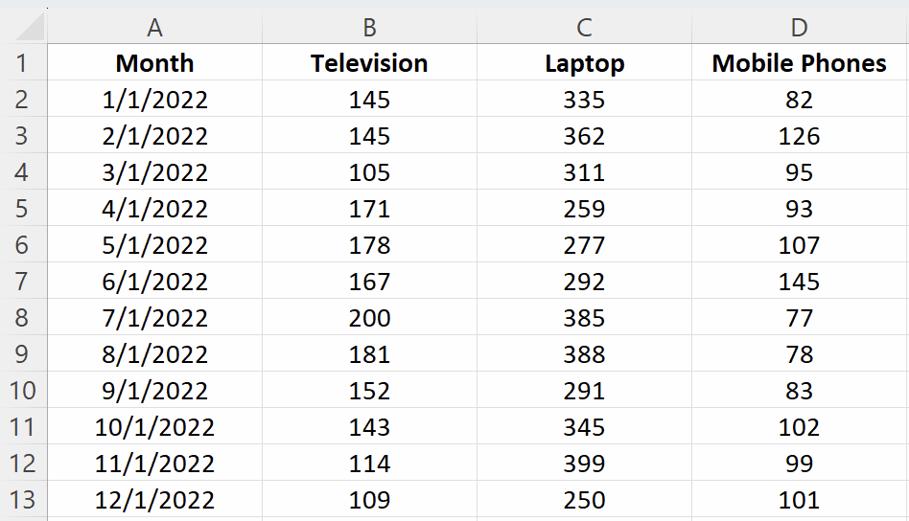

Creating Basic Charts in Excel

Excel has multiple options for choosing a particular chart type. For example, if you want to create a column or bar chart, you are often presented with various visualization options. For example, there are 2D and 3D versions and normal, stacked, and 100% stacked options. Depending on your requirements, you can choose the visualization type that best suits your needs.

98 Department of Artificial Intelligence and Data Science, APCOER, Pune
Computer Laboratory-IV B.E.(Sem-II) | [2024-15]

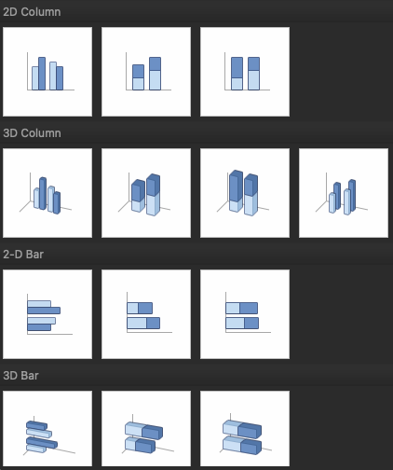
Excel bar charts
Bar charts are one of the easiest charts to interpret, enabling the person viewing the chart an easy way to
compare categorical data quickly. On a bar chart, the categorical data is on the y-axis, and the values are on the x-axis.
To create a bar chart:
- Select the data range A1:D13
- Click the "Insert" tab in the Excel ribbon
- Click on the columns icon button dropdown, and under the “2-D Bar” category, choose “Clustered Bar”

99 Department of Artificial Intelligence and Data Science, APCOER, Pune
Computer Laboratory-IV B.E.(Sem-II) | [2024-25]

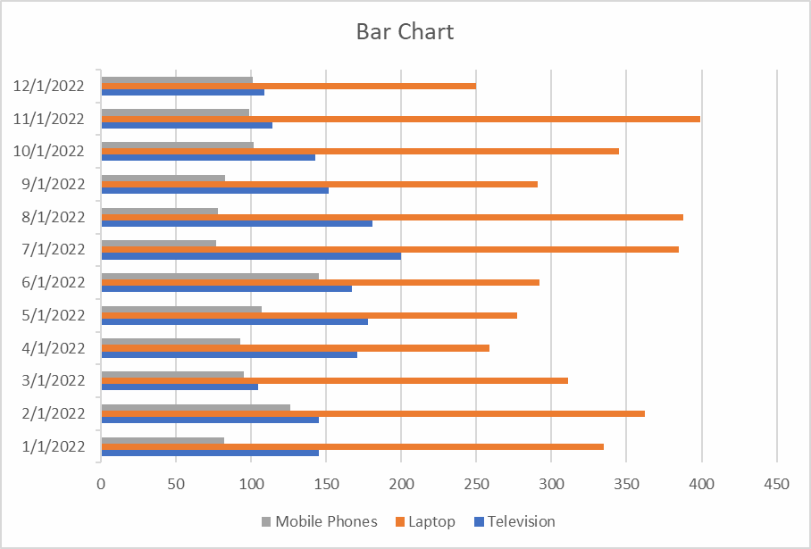
Excel column charts
A column chart, also known as a vertical bar chart, helps visualize data where categories are placed on the x- axis and the values on the y-axis. Similar to bar charts, they help visualize data across categories.
To create a column chart in Excel:
- Select the data range A1:D13
- Click the "Insert" tab in the Excel ribbon
- Click on the columns icon dropdown, and under the “2-D Column” category, choose “Clustered Column”
You can now see a column chart that displays the number of units sold for each product category by the month.

100 Department of Artificial Intelligence and Data Science, APCOER, Pune
Computer Laboratory-IV B.E.(Sem-II) | [2024-25]

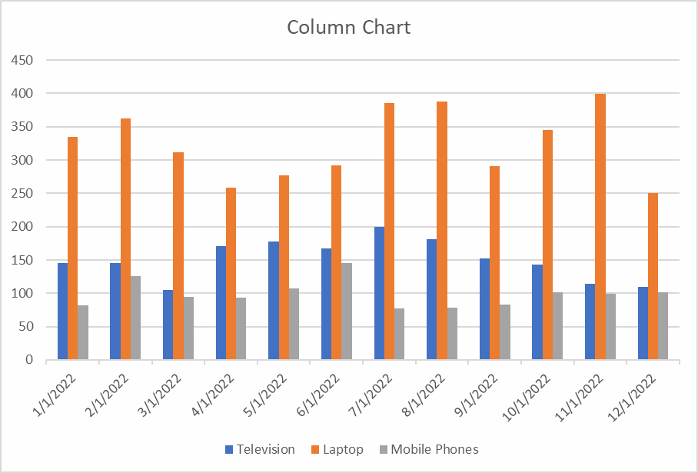
Excel line charts
A line chart is the most useful way to capture how a numerical variable changes over time. This is helpful to identify trends in numeric values.
To create a line chart in Excel:
- Select the data range A1:D13
- Click the "Insert" tab in the Excel ribbon
- Click on the line chart dropdown, and under the “2-D Line” category, choose “Line with Markers"
You can now see a line chart displaying units sold each month split by product category. This enables you to compare each product category's performance over time easily.

101 Department of Artificial Intelligence and Data Science, APCOER,Pune
Computer Laboratory-IV B.E.(Sem-II) | [2024-25]

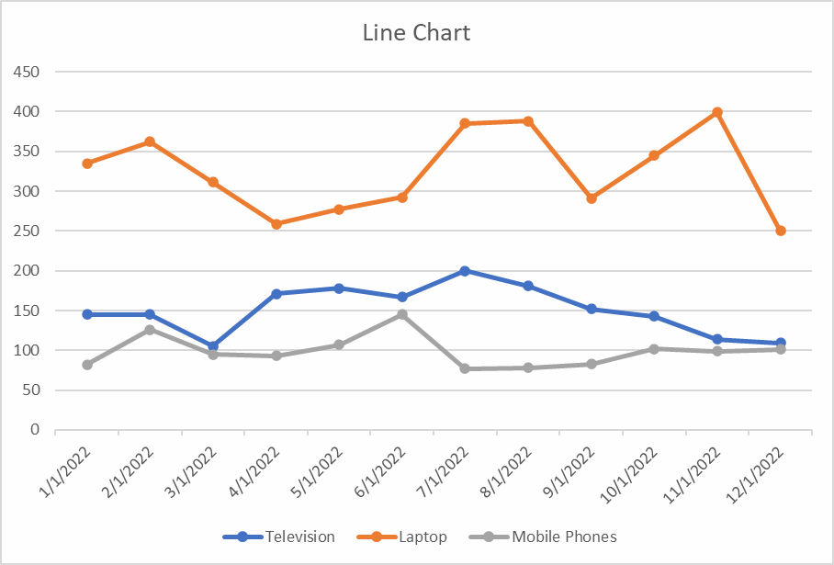
Excel pie charts
A pie chart is most commonly used to show the proportions of a whole. It’s like visualizing fractions when you were in high school. With this pie chart, we want to compare the total sales between the three categories.
To create a pie chart in Excel:
- First, select the data range B1:D1
- Second, using the command (for Mac) or ctrl (for Windows), select the second date range: B14:D14
- Click the "Insert" tab in the Excel ribbon
- Click on the pie chart dropdown, and under the “2-D Pie” category, choose “Pie”

102 Department of Artificial Intelligence and Data Science, APCOER, Pune
Computer Laboratory-IV B.E.(Sem-II) | [2024-25]

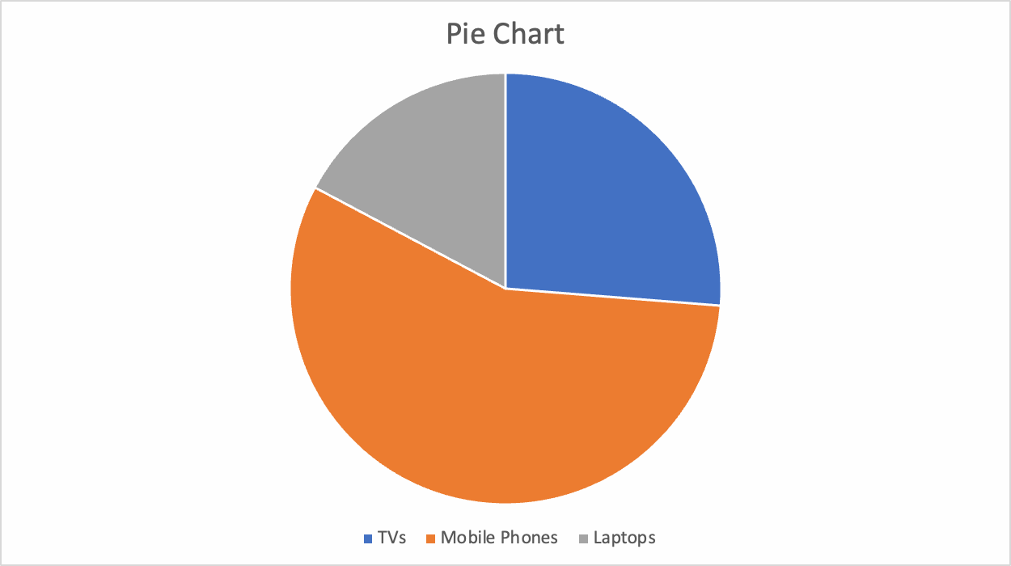
Advanced Excel Visualization Techniques Excel scatter plots
A scatter plot is commonly used to visualize the relationship between two variables. It can be useful for quickly surfacing potential correlations between data points. We’ll create a scatter plot to compare the number of TVs and laptops sold.
To create a scatter plot in Excel:
- Select the data range A1:C13
- Click the "Insert" tab in the Excel ribbon
- Click on the scatter plot dropdown, and under the “Scatter” category, choose “Histogram”
- Click "Scatter or Bubble Chart" and choose "Scatter with Smooth Lines and Markers"

103 Department of Artificial Intelligence and Data Science, APCOER, Pune
Computer Laboratory-IV B.E.(Sem-II) | [2024-25]

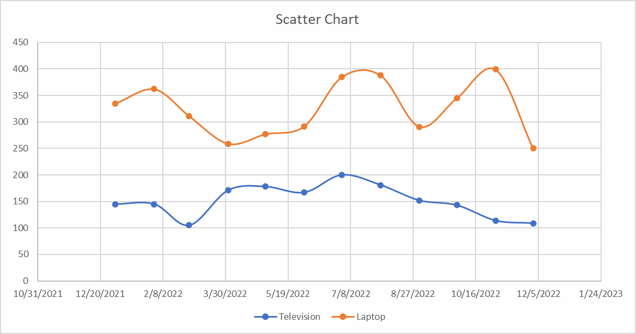
Excel waterfall chart
A waterfall chart is a special chart that helps illustrate how positive and negative values can contribute to a total. They can be great for visualizing changes over time. In our example, we’ll compare the total sales for each month regardless of the categories.
To create a waterfall chart in Excel:
- First, select the data range A2:A13
- Second, using the command (for Mac) or ctrl (for Windows), select the second data range E2:E13
- Click on the waterfall chart dropdown, and under the “Waterfall” category, choose “Waterfall”
We’ll only see positive values in our example because the Total column only contains positive values, but this chart can be great for comparing financial data and changes over time.

104 Department of Artificial Intelligence and Data Science, APCOER, Pune
Computer Laboratory-IV B.E.(Sem-II) | [2024-25]

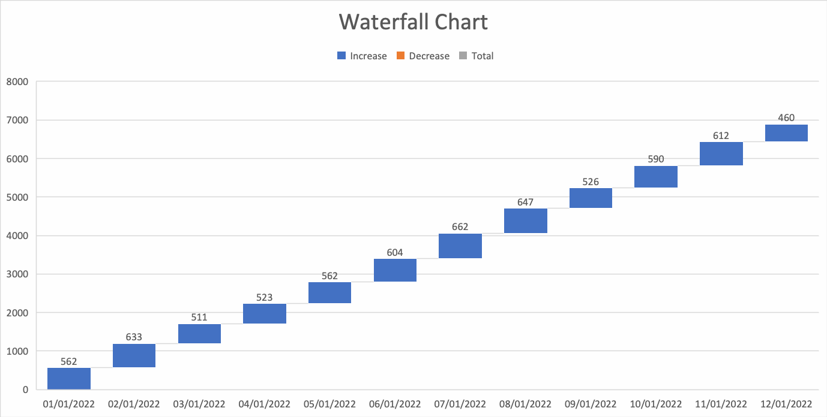

Customizing and Formatting Excel Charts

Aside from creating charts in Excel, there are many options to customize and format a chart. From here, we’ll discuss some common formatting options that’ll help you enhance your visuals.
First, create a column chart based on our previous guidance that displays the number of units sold for each product category by the month.
Chart elements
Chart elements include titles, legends, data labels, gridlines, and axes. You can add, remove, or modify these elements as needed.
Click on the chart to select it.
- In the Excel ribbon, click the "Chart Design" tab
- Click the "Add Chart Element" dropdown to access the available chart elements

105 Department of Artificial Intelligence and Data Science, APCOER, Pune
Computer Laboratory-IV B.E.(Sem-II) | [2024-25]

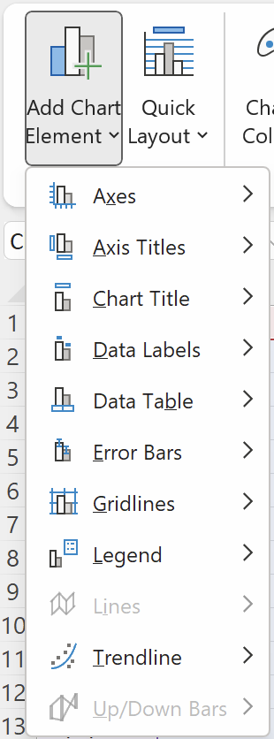

Chart title

106
Department of Artificial Intelligence and Data Science, APCOER, Pune

Computer Laboratory-IV B.E.(Sem-II) [2024-25]

- To add a chart title, click "Add Chart Element" > "Chart Title" and choose one of the available
options (e.g., "Above Chart" or "Centered Overlay"). You can then click the title placeholder and type your desired title
- To remove a chart title, right-click on the title and select “Delete” For this tutorial, rename the chart “Electronic Store Sales 2022”
Legend
- To modify the chart legend, click "Add Chart Element" > "Legend" and choose a position for the legend (e.g., "Right" or "Top")
- To remove the legend, click "Add Chart Element" > "Legend" > "None" For this tutorial, move the legend to the top of the chart.
Data labels
- To add data labels, click "Add Chart Element" > "Data Labels" and choose one of the available options (e.g., "Center" or "Above"). This will display the data values directly on the chart
- To remove data labels, click “Add Chart Element” > “Data Labels” > “None”
- To remove data labels from individual categories, right-click on the data label of the chosen category; this will highlight all relevant data labels. You can then click “Delete”
For this tutorial, add data labels for all categories. Your chart should now look like this:

107 Department of Artificial Intelligence and Data Science, APCOER, Pune
Computer Laboratory-IV B.E.(Sem-II) | [2024-25]

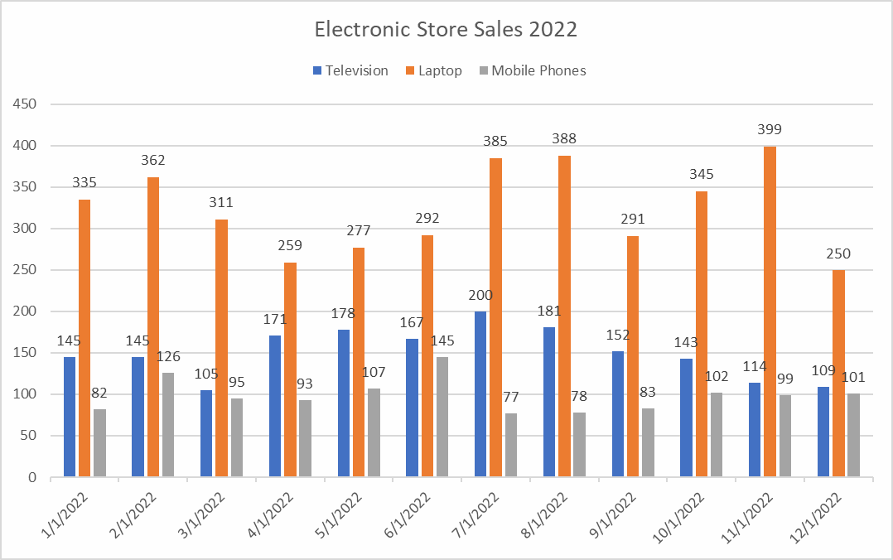
Chart Styles and colors
On top of customizing individual chart elements, you can change your chart's overall look and feel by applying different styles and color schemes.
To customize a chart style, select the visual you want to update. Then take the following steps:
- In the Excel ribbon, click the "Chart Design" tab
- Under the “Chart Styles” section, there is an option to change styles and change colors
- For chart styles: Browse the available styles and click one to apply to your chart
- For color changes: Click the “Change Colors” dropdown and choose a color scheme

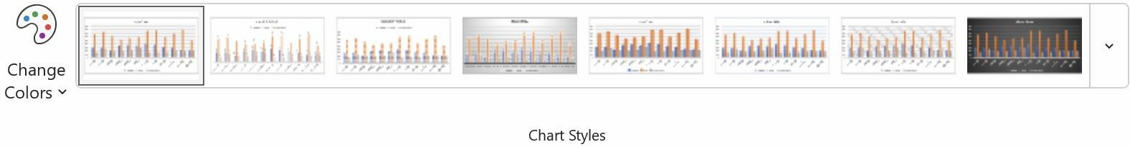

108 Department of Artificial Intelligence and Data Science, APCOER, Pune
Computer Laboratory-IV B.E.(Sem-II) | [2024-25]

By implementing small visual changes, we can see a big difference in the aesthetic of the whole chart.
Here’s an example of how our chart has changed by choosing Style 6 and Monochromatic Palette 8.

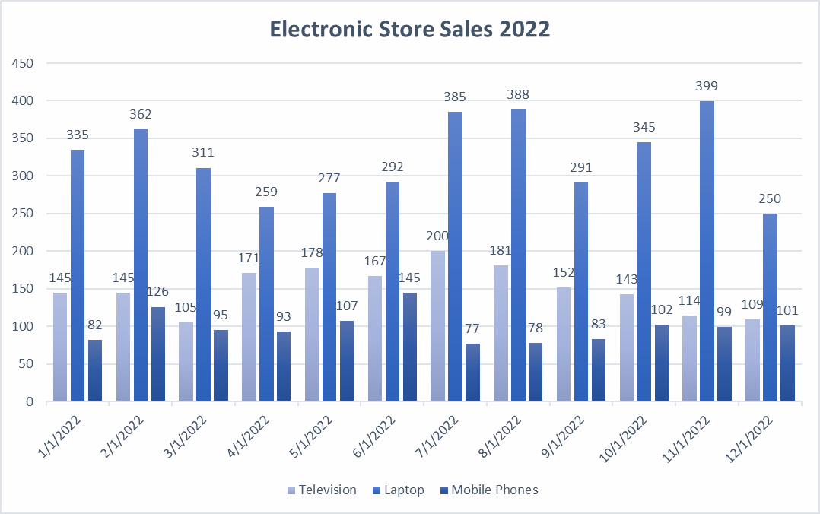

Formatting Excel chart axes
To improve the readability of our chart, we can format our axis in several ways, including axis titles, scale, or even visibility.
Axis titles
- To add an axis title, click "Add Chart Element" > "Axis Titles" and choose "Primary Horizontal" or "Primary Vertical." You can then click the title placeholder and type your desired title
- To remove an axis title, right-click on the axis title and click “Delete” For this tutorial, add an x-axis title “Month” and a y-axis title “Products Sold.” Axis scale and number format
To adjust the axis scale or number format:
109 Department of Artificial Intelligence and Data Science, APCOER, Pune
Computer Laboratory-IV B.E.(Sem-II) | [2024-25]

- Right-click the axis you want to modify and choose "Format Axis"
110
Department of Artificial Intelligence and Data Science, APCOER, Pune
In the "Format Axis" pane, you can change the minimum and maximum values, major and minor units, or number format.
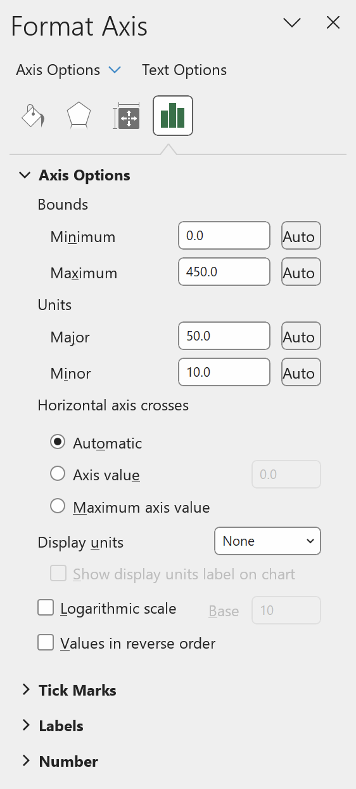

Computer Laboratory-IV B.E.(Sem-II) [2024-25]

For this tutorial, we intend to keep these options the same but feel free to play around and test what each
does.
Axis visibility
Finally, if you would like to remove the axis labels from showing, you can take the following steps:
- In the Excel ribbon, click the "Chart Design" tab
- Click the "Add Chart Element" dropdown and navigate to "Axes"
- By default, both options will have a darker gray box surrounding them, to remove an Axes, simply de-select the axes you’d like to remove

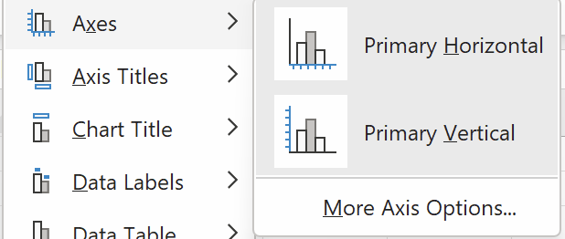
Other Excel formatting options
There are other formatting options available, including modifying data series colors, adjusting chart and plot area backgrounds, and customizing gridlines.
To access these options:
- Right-click the chart element you want to modify (e.g., data series, plot area, or gridlines)
- Select "Format [element]"

111 Department of Artificial Intelligence and Data Science, APCOER, Pune
Computer Laboratory-IV B.E.(Sem-II) | [2024-25]

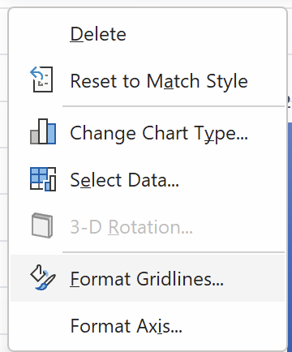

Conclusion:- Thus, this way Data Analysis and Visualization is done using Advanced Excel.

112
Department of Artificial Intelligence and Data Science, APCOER, Pune

